Ice Breakers Cool Blast Chews Collegiate Case Competition

Northeastern University Marketing Association

Maria Bermudez
Margie Bogart
Anna DeSapio
Alex Dfouni
Ashley Frizzell
Katherine Hayes
Kevin Ng

Situation Analysis
In order to create a relevant and powerful campaign, a situation analysis was conducted to ensure that the proposed marketing campaign would be supported by industry trends and the overall vision of The Hershey Company. We started with an analysis of the the mint and gum markets. As mentioned in the case, the mint and gum markets in the United States have been through a lot of changes in the past few years, the main one being shifting consumer preferences that resulted in a decrease in popularity of gum given the decrease in social acceptability of gum. However, this shift in the market has been identified as an opportunity that Ice Breakers Cool Blasts Chews could leverage with the right marketing campaign. Furthermore, the increasing interest in faster and more discreet breath freshening adds to this opportunity and gives Ice Breakers a first-mover advantage to tap into the gum market, and perhaps create a new one that includes the hybrid between gum and mint that they have created with Ice Breakers Cool Blasts Chews.
A SWOT analysis was conducted in order to recognize the strengths of the Ice Breakers brand, identify weaknesses and threats, and leverage them to convert them into opportunities. One of the most powerful strengths identified in the Ice Breakers brand are the visible cooling crystals. During the primary research conducted, the cooling crystals were
one of the things that people first identified and thought of when the words “Ice Breakers” were mentioned. Similarly, in terms of flavor, peppermint, spearmint and wintergreen (which are the flavors featured in Ice Breakers products) are amongst the top flavors that are most consumed in the gum market (Ferdman, 2014).
Furthermore, The Hershey Company has announced recent partnerships (such as their 5-year US Olympic and Paralympic partnership) and the launch of global social programs such as the Nourishing Minds program which will provide children in the United States and abroad with the basic nutrition that is critical for them to learn and grow (SwimSwam, October 2015). This has the potential to increase customer loyalty and create greater consumer awareness, resulting in an opportunity to increase and secure market share, positioning the company as a supporter of praiseworthy causes, and create a positive impact in public opinion.
In terms of innovation, The Hershey Company has constantly stayed relevant in the confectionery industry by releasing products that respond to trends and customer demand. Products such as Reese’s Spreads Snacksters Graham Dippers, Kit Kat White Minis, Hershey’s Caramels, and now Cool Blasts (that were released in 2015, as mentioned in the 2014 Hershey’s Annual Report), have allowed the company to take advantage of the well-known names of their existing brands and use them to release new products and extend their product line to potentially attain greater market share and increase the number of sales.
In terms of opportunities in the market, given that The Hershey Company is the seasonal confectionery leader in North America with more than 78% share and all 10 of the top 10 seasonal items (BusinessWire, 2015), the opportunity to successfully release seasonal products has been identified. Additionally, the increase in more frequent snacking habits could potentially create an opportunity to position Ice Breakers Cool Blasts Chews as a complement to snacks and an easy option (even easier than the current ones available given the product’s ability to dissolve after a few chews) for fresh breath.
Similarly, “natural gum” (gum made with fair trade sugar, the minimum amount of preservatives or flavouring, and with packaging made out of recycled materials, for example) has presented a steady, strong growth in popularity in the gum market (McMillan, 2014). According to recent research, customers want something simple and uncomplicated, and they’re getting more critical and concerned about the things that they eat (McMillan, 2014). Glee Gum, for example, is the only gum in the United States to be non-GMO project verified, and it is the top selling all-natural gum brand in US (according to SPINS, a research firm that specializes in natural products).
Similarly, PUR Gum, which promotes their gum through the tagline “kick aspartame”, offers naturally sweetened, low-calorie gums, and emphasizes the use of the natural sweetener xylitol rather than chemical sweeteners. Not only was it incredibly popular in its initial launch, but it also has experienced a growth of about 200-300% per year in sales since 2010 (Nieburg, 2014). However, these brands are not getting big market share because of the fierce competition for prime space in supermarkets and impulsive buying lines. Given that Hershey has the advantage of being a well-established brand with multiple partnerships and good relationships with supermarket chains and multiple stores that sell their products, this could be a good opportunity to tap into to increase market share and achieve customer loyalty amongst customers that are environmentally conscious and concerned about consuming genetically modified foods.
Additional opportunities in the industry include recent packaging trends that have revealed a boost in sales when brands use see-through packaging, given the consumer desire for transparency on production of confectionery products and companies overall (Nieburg, 2014). Likewise, flip top carton packaging with fewer pieces showed increasing popularity since November 2014 (Confectionery News: Nieburg, November 2014). In terms of use, sugar-free gum and gum with dental-health benefits has become an increasingly popular category since the recent prevailing concern regarding sugar intake. In 2000, for example, sales of gum with and without sugar was fairly close in the US—$930 million and $1.1 billion, respectively. Since then, according to Ferdman, 2014, that gap has increased dramatically, and in 2013 sugar-free gum sales went up to under $3 billion, while sugared gum sales fell below $500 million (Ferdman, 2014). Although the Ice Breakers products are labeled as “sugar-free” in their packaging, through primary research it was discovered that not many customers identify this characteristic in the Ice Breakers brand, but if marketed more aggressively, could be a great opportunity to boost sales. Moreover, given the annual growth rate (more than 19.6 percent in the last four years) in C-store and seasonal confectionery sales (BusinessWire, 2015), Ice Breakers Cool Blasts Chews has an opportunity to increase seasonal sales in holidays or special days for confectionery customers such as Valentine’s Day.
Finally, the recent development in smart displays and Wi-Fi marketing has created technological opportunities that can allow customers to interact with and to know more about products in a faster, easier way. Recently, Mondelez, who makes Trident, partnered with Shelfbucks, a company that has developed technology that allows customers to engage with smart display to see product reviews and multimedia content on their cellphones as they approach the shelves (Nieburg, September 2015), in an intent to provide better product information to their customers and create a better shopping experience.
Compared to the available opportunities, Ice Breakers faces a small amount of threats, that nevertheless must be considered. A threat that Hershey’s as a whole faces regarding Ice Breakers is the lawsuit that was filed against Hersheys in June of 2015 because of the claim that the packaging of (Ice Breakers) gum contained unneeded space and was therefore deceiving customers (Zinck, July 2015). This public relations issue has been handled well so far, given that a considerable amount of research on our end had to be done to find an article that mentioned the lawsuit, but it should not be disregarded.
On a broader scale, recent research in the gum industry has shown that the whole industry faces the threat of getting caught in segmenting their products too much, which results in them fighting for shelf space at retail stores, locations, and places in the mind of the consumers. This also results in a clog in the supply chain because too many items (that are almost the same) need maintenance, and have to be supervised and moved constantly given the differences in their life cycles (Van Bodegraven, 2015). Not only does this affect the internal parts of a business, but also the relationship with consumers, given that with too many segmented and niche products, consumers will become confused and faced with too many choices, which will have an adverse effect on their purchasing decisions and potentially decrease demand. On that same note, gum is seen as a mature product in the US and Canada while in other parts of the world it’s seen as “American and different” (TheGlobeandMail, 2015). This poses a threat to all gum companies in the United States, which could be adding to the recent decrease in gum consumption in the country.
In terms of competition, given that Ice Breakers Cool Blasts Chews do not belong to a particular category but rather to both the gum and breath fresheners category, they face competition in these two areas of the confectionery industry. In the gum category, Ice Breakers faces tough competition from companies such as Orbit, Dentyne Ice, 5 Gum, Stride, Extra, and Trident, whose products are very similar. Both of these companies products’ in the gum category have similar packaging and characteristics as Ice Breakers products, and there is little (if any) difference between them, however, according to Statista, both Trident and Orbit surpassed Ice Breakers in sales in 2013, and were above Ice Breakers in the leading sugarless gum brands in the United States in 2015 (Euromonitor 2015).
In the breath fresheners industry, Ice Breakers faces competition from Altoids, TicTac, Mentos, and Breath Savers, amongst others. Again, their products are quite similar, except that their packaging differs one from another. On the promotion end, both Trident and Mentos have more compelling and attractive websites and online presence compared to the Ice Breakers brand. Additionally, Listerine Strips also compete with Ice Breakers in this category, and we consider them a strong competitor in the sense that their strong freshening power is very similar to the Ice Breakers visible cooling crystals.

Market Research
With any case analysis, it is essential to conduct both primary and secondary market research. The group took advantage of utilizing Qualtrics, a private research software company, to assist with the implementation of a questionnaire to college students (as this is the primary target market). The main objectives of this questionnaire were to determine college students consumption and purchasing habits of gum and mints, their perception of the Ice Breakers brand (and specifically that of Ice Breakers Cool Blasts Chews), and their tendency to purchase Ice Breakers or Ice Breakers Cool Blasts Chews.
With a sample size of 93 respondents and a sample frame of the research group’s social media followers (which is then generalized to the entire college-aged population in the US), it is important to consider non-response bias and sample frame error. The majority of those sampled were aged 20 - 23 (85%) and were female (73%). Regardless of the sample demographics,, there are still definitive results that can be concluded from this questionnaire.
First, it is interesting to note that 53.4% of all respondents like both gum and mints, but when forced to choose between gum and mints, 73.6% of respondents prefer gum. Of all respondents that prefer gum over mint, having a wrapper is a desirable quality by 64.3%.
In terms of brand awareness, 93% of our respondents were familiar with Ice Breakers but only 47.8% were familiar with Cool Blast Chews. Of that number, only 10% of all respondents have actually purchased the Chews. While 93% of those surveyed are familiar with Ice Breakers, only 8.1% of purchase a product from this brand often. There is clearly a disconnect with awareness of Ice Breakers and purchasing tendency, and there is also a disconnect between the launch with Cool Blasts Chews and awareness levels. It is thus our task to create a campaign centered around strengthening the Ice Breakers brand while promoting awareness and eventual purchase of Ice Breakers Cool Blasts Chews.
The gum brand that participants quote as to purchasing most is 5 Gum, and the preferred location is convenience stores. Distribution will focus on convenience stores as a priority (as it currently is) located near colleges and universities to reach the target market efficiently. The notation of 5 Gum being most popular is also interesting as that brand focuses on the experiential aspect of chewing gum and the sensations felt during consumption. Ice Breakers should also focus on experiences related to consumption of the Chew in this regard.
When asked why they chew gum, respondents in a focus group conducted over the course of an hour replied in various manners. Some said after a meal gum is a great breath-freshener, while others use it to mask the scent of alcohol when going out and drinking. It is also used when socializing or when students are bored in class. Gum also has utilitarian functions as it can be used on planes during takeoff or landing to help the uncomfortable ear-popping sensation. Yet others use gum because of its health benefits (dentist-recommended, kills germs, etc.). In the Qualtrics questionnaire, 91% of respondents cited freshening breath after eating as the number one reason for gum or mints consumption.
Other notable statistics found in the questionnaire are that more respondents link the Ice Breakers brand to mints over gum, all respondents stated that Ice Breakers was related to the word “fresh,” and 71% of respondents believe that Ice Breakers products are “flavorful.” Lastly, most respondents are neutral when associating the word “innovative” with Ice Breakers. Based on these findings, we will look into positioning Ice Breakers Cool Blasts Chews as a mint over a gum and employ promotions that center on first raising awareness of the new product and educating consumers on its functions. Ice Breakers may also be able to take advantage of the “fresh” association with the Ice Breakers brand and their proprietary cooling crystals to promote as a breath freshener.
Choosing the right brand varies on the consumer. Most respondents in the focus group agreed that price contributes to the make-or-break buying decision. Purchasing a three-pack of gum provides more value as overall volume is purchased at a lower price. Because quality doesn’t differ much from brand to brand, price could be a big differentiator. Along these lines, some consumers look at the number of sticks per pack, also relating to the “bang for your buck” phenomenon. Lastly, consumers look at packaging to help with their purchasing decision of choosing one brand over the other. Is the pack convenient for your car? Will it fit easily in your purse or pocket? Is it easily suitable to throw in your backpack? As millennials are our target market, we must determine what traits they specifically are looking for in a product and what packaging criteria pairs best with our product.
The debate for gum versus mint has been around for centuries. When we asked the focus group this question there were universally accepted pro’s for each category. First, mints are a product that you do not have to spit out. They are a short-lived breath freshener; gum is just the opposite. There was one con highlighted with gum, however, and that is the fact that chewing gum can be obnoxious. It is interesting to note this as the Ice Breakers Cool Blasts Chews advertisements were shown to focus group participants after this question/answer session, but this was still an association with gum even prior to the ad that showcased just how annoying that chewing may be.
In the focus group, participants were asked to say what came to their mind when the word “Ice Breakers” was spoken. Some responses were cubes, games, Titanic, Ice Breakers mints packaging (the “puck” share/not share container), and Ice Breakers Sours. When actually tasting the Chews, participants were confused if they were supposed to swallow the Chew, felt as though they were eating mouthwash, or felt as though it did not last long enough and thus shouldn’t be called gum. Another dislike associated with eating the Ice Breakers Cool Blasts Chews was that the experience was a surprise - it was an unexpected sensation, not a pleasant surprise but a disruption to their current perception of gum chewing or mint consumption. There were positive attributes to this product as well. Ice Breakers Cool Blasts Chews are distinguishable as they are “super minty,” they are not just another hard mint, they quickly disappear which is “handy in some situations,” they aren’t too big, they have a good flavor and are good for chewing, they disappear quickly while the mintiness lasts, and have a texture reminiscent of fancy dinner mints.
Packaging on the Ice Breakers Cool Blasts Chews is analyzed as a container that doesn’t fulfill its purpose. The chews could fall out as the technology doesn’t sturdily lock the sliding tray in place, and it is confusing which side is up and which way the container should face for the tray to come out properly without spilling the chews inside. Additionally, if Ice Breakers Cool Blasts Chews are positioned as a product that is used for dating, the tray is not discrete enough to fit in a pocket and easily slip out a chew. It is suggested to utilize a PEZ-type flip top for even easier extraction and discretion.
Given all feedback from primary research, it can be concluded that Ice Breakers Cool Blasts Chews’ number one issue is defining its category and raising awareness. Our focus group left the researchers with some tips for establishing Ice Breakers Cool Blasts Chews as a new brand. It was suggested that Cool Blasts Chews are an intriguing and curious product, and campaigns centering around this product may focus on creating curiosity. It was also suggested that the company create a new term for the chew, as is it neither a gum nor a mint. One example is replacing “Chew” with “Melt” to convey the short time span the product exists in your mouth, which is also a differentiating factor of this new innovation from Ice Breakers. The product isn’t chewy like a Starbursts, so there is a current incongruence between the name and the product. It may also be helpful to include consumption instructions or convey consumption methods in commercials as participants were unsure whether they could swallow the Chew. The number of pieces in packaging and the dissolvability factor relate this product more to mints than gum. Suggested uses for this product include dating and smoking due to convenience and minty intensity (though not to the same extreme level as Listerine Strips). Lastly, it is important to consider the target market for this product (which both our focus group and those surveyed via the Qualtrics questionnaire fit). All focus group participants agreed that if the Cool Blasts Chews were priced right, they might try the produce. This relates to the purchasing power of Millennials and their willingness to spend their disposable income, and what they are looking for in price of a mint or gum. The next section further elaborates on these aspects and others of the millennial target market.

Target Market
The current target market of the Ice Breakers Cool Blasts Chews are Millennials, whose ages range between 18 and 24, which could be labeled as the “younger Millennials”. The Millennial market as a whole is 77 million, which makes up 24% of the US population, equivalent with the Baby Boomers.
In terms of demographics, geographically millennials are an urban population, mostly concentrated in the Western United States. Economically, they are still climbing the income ladder, with a median income of $25K for Younger Millennials, and $48K for Older Millennials. They are optimistic and ambitious, and, while they prioritize getting a good deal, they care about making a social impact, which makes them more willing to pay for and pay attention to companies with social impact programs, with education, poverty, and the environment being the causes they care the most about. They care about being philanthropic, to the point that three-quarters of Millennials made a financial gift to a non-profit in 2011, but always within their means, typically less than $100. In general, even though they can’t make large donations, they contribute to causes they care about in other ways, with 71% of millennials raising money on behalf of a non-profit, and 57% doing volunteer work in the past year - a higher percentage than any other generation.
Millennials embrace technology as a way of life, to the point that 83% of them sleep with their mobile devices and post status updates “from the bathroom”. However, in terms of media channels, they are more likely to spend time in social media than watching TV. While they do watch TV, and are more likely to watch event-related programming like Sunday Night Football or cable programming on BET, Comedy Central or FX Network, they’re also engaged with social media, commenting about what they like and dislike about a TV storyline, in line with their expressive nature. The number one app used by Millennials is Facebook, which is a platform for 72% of the market. In terms of mediums, younger Millennials (age 18-24) spend slightly more time on social media on their laptops compared to mobile Web apps (11 hours per month on their laptops vs. 10 hours per month using mobile Web apps).
In terms of brand interaction and product consumption, Millennials like personal and direct interactions, and value a customized experience paired up with authenticity on social media.They’re influenced by celebrity endorsements and respond more favorably to advertising that features celebrities, relatable characters or strong visual elements tied to their expressive, creative nature. They are particularly receptive to endorsements by music artists they like. 24% of Young Millennials and 26% of Older Millennials will try a brand/product if they sponsor an event for a music artist they like. Millennials ranked “Technology Use” as the most defining characteristic of their generations (24%), followed by “Music/Pop Culture” (11%) and Liberal/Tolerant (7%), which further exemplifies the proliferation of technology and social media in this segment and their focus on music to express themselves artistically (Millennials - Breaking the Myths, 2014)
It has been shown millennials are very concerned of their image and perception. Therefore, they are very concerned with how they are viewed by their peers. “They use scented deodorant multiple times a day and brush their teeth four times daily on average” (Milward Brown Research, 2015). Fresh breath is very important when it comes to dating. Usually, teenagers are insecure about their breath before they kiss their date. The Ice Breakers Cool Blasts will allow them to freshen their breath fast and easily. Including the not to share and to share options on the packaging will make it less awkward because they can offer their date a mint. With regards to the importance of fresh breath while dating, in a recent Dentyne Safe Breath Survey, 86% of people surveyed said that having bad breath on the first date could not be overlooked (ProFresh, 2015). On that same study, 58% of people said that bad breath had caused them to lose interest in someone and 48% of women surveyed said they would stop seeing someone who had an ongoing bad breath problem (ProFresh, 2015).
Looking at the big picture, each year, Americans are estimated to spend their money to the tune of nearly $3 billion a year on fresh breath remedies, including gum, mints and mouth rinses (Newbrun, 2008). In addition, according to a U.S. phone survey, 60% of women and 50% of men say they use cosmetic breath freshening products like candies, chewing gum and sprays (Newbrun, 2008).
Not only is fresh breath important to millennials, what they are doing once their breath is refreshed is remarkable. Casual hookups are becoming more likely in “younger people” as opposed to romantic sex, cited by an Inquisitr article in December 2015. It was found in studies conducted by University of Iowa News Services that a non-monogamous lifestyle preference decreased by 44 percent for women and 25 percent for men when being involved with a friend, and 30 percent for women and 43 percent for men when involved with a stranger. Numbers suggest that these younger people are more likely to “have casual sex and less romantic sex.” This focus on the hookup up casually versus sustaining a romantic relationship is a big factor in the target market's new lifestyle decisions.
Additionally, recent studies have found that Millennials are the most likely to acknowledge having casual sex in comparison to other generations, such as Generation X. A total of 45% of Millennials said they had slept with someone other than a boyfriend/girlfriend or spouse when they were in their late teens or 20s, while when Gen Xers were that age, only 35% of them said they had sex with someone who wasn’t their significant other (Kaplan, 2015). Mobile apps like Tinder and the Grade have made hookup culture more accessible.
Overall, hooking up “makes sense” in this culture, especially for millennials, as modern society centers around speed to delivery and efficiency. Our “competitive, media-driven world” (Huffington Post) focuses on satisfaction, something that this proliferation of hooking up within the millennial demograph enocmpassses as well.

Positioning
Ice Breakers Cool Blasts Chews is currently positioned as an alternative to gum as it doesn’t require noisy chewing yet still provides a cool refreshment to your breath. Gum is portrayed in a negative manner in both animated TV commercials Ice Breakers is currently promoting, claiming that chewing gum will will eat up the success of your date or night out.
It is recommended to retain the suggested uses of the gum, as the outline of the target market depicts a consumer that is engaged a hookup culture and going out, so it is relevant to showcase the Chews’ uses as something that will freshen your breath before a date. Emphasis should be placed on the experiences revolving around chewing an Ice Breakers Cool Blast, appealing more to hedonic needs than utilitarian needs. We will use the hashtag “have a blast” to promote this theme of experiential marketing.
Lastly, Ice Breakers Cool Blasts Chews must focus on educating consumers once the product is actually in their hands. The focus group, once trying the Chew, was unsure how to actually consume it. Yes, it’s not a gum and not a mint, but how are you supposed to eat it? The product can continue to be positioned as a cross between and gum and a mint yet there must be some educational aspect related to consumption and the experience.

Strategy
Execution of a new marketing campaign includes a twofold strategy. First, to increase awareness of the new product Ice Breakers Cool Blasts Chews, and second, to drive purchase of Ice Breakers Cool Blasts Chews.
Our first component of our strategy is to raise awareness with the target market through mediums which they currently utilize. This will be further developed in the budget, but includes social media outlets, celebrity endorsement, and print (magazines) that the target market purchases. It was found in our primary research that of those who have heard of Ice Breakers brand, only half have heard of Ice Breakers Cool Blasts Chews. It is thus important to first raise awareness of this new product by utilizing Ice Breakers brand recognition. The brand will be leveraged in packaging and promotions.
The second component of the campaign is to drive purchases of Ice Breakers Cool Blasts Chews. This will primarily be executed with the use of experiential promotions centering around four holiday seasons and the concept of using the Chews in fun situations, associating Cool Blasts Chews with a fun night out and an essential component of the experience.
.
Objectives
With this two-part strategy comes quantifiable objectives. To quantify increased awareness of Ice Breakers Cool Blasts Chews, we will look at reach and engagement with viewers on social media (flushed out in the “Metrics” section of this report). The metrics will report reach, which will be measured by looking at page views and impressions whereas engagement will be measured through likes/favorites, comments, and shares on posts.

Master Marketing Budget
Many methods of advertising were considered throughout the budgeting process. Favorite options such as a partnership with Tinder were cut due to the low amount of transparency Tinder has surrounding advertising/partnership activities. Furthermore, Tinder does not currently offer any metric analysis tools to measure conversion rates, unlike other options. We have also ruled out doing any television advertising or YouTube advertising as both mediums are interrupting an experience and mostly ignored by our millennial target market. In the end, a campaign that respects our millennial target audience was comprised of social media and print magazine advertising along with a substantial amount of celebrity endorsements.
The largest portion of our budget by 10% is dedicated to Facebook and Instagram advertising. Facebook and Instagram are both highly engaged with by millennials and offer metric analysis tools to measure conversion. 40% of our budget is dedicated to reaching out to anywhere between 3,900,000 and 8,400,000 Facebook and Instagram views a day for an entire month, four times. Running up at the second largest portion of our budget is the 30% portion dedicated to Snapchat advertising. Snapchat is booming, especially with millennials. Many brands have run successful ad campaigns on the Snapchat platform and Ice Breakers Cool Blasts Chews intends to as well on 4 specific days of the year. These days will revolve around holidays or other nationally covered events (Valentine's Day, the Fourth of July, Halloween, and New Year’s Eve are the four candidates currently). These four specific days of the year will also see accompanying promotions inside cover magazine ads (for the months of February, July, October, and December to revolve around those four holidays), promoted hashtags on those days specifically, both large and small magazine ads, as well as coupons. Those efforts cost 20%, 8%, .8%, .15%, and .05% portions of the total budget, respectively. The other 26 small magazine ads will be spread out between three other magazines for nearly the entire year, each. Potential magazine publications include Cosmopolitan and Glamour for women, GQ for men, and Seventeen for the younger section of our target market. The remaining 1% of our budget, $100,000, will be entirely dedicated to pushing the Ice Breakers Cool Blasts Chews brand through celebrity endorsements. Whether it is through media or a simple Twitter shoutout, celebrity endorsements have timelessly proven to push conversions with millennials. Candidates for likely celebrity endorsement offers include Katy Perry, Amy Schumer, Steph Curry, and YouTube pranker Vitalyzdtv.
Facebook recently decreased the organic reach for fan pages, meaning that only a portion of users who liked the Ice Breakers page will see a post unless Ice Breakers were to pay to “boost” the post - a form of paid advertising. The Ice Breakers Facebook page is a worthy platform for paid advertising as they already have an existing fan base of 1,114,607 likes (November 22nd, 2015). The Facebook tool allows businesses/users to choose their audience and budget based on how many people you want to reach and how long you want the “boost” to run. This method of paid advertising has its benefits by giving businesses the ability target a specific demographic. Ice Breakers can boost posts from other marketing initiatives to achieve a greater reach.
To raise awareness for its new Cool Blasts Chews, Ice Breakers will also utilize YouTube to create a viral campaign, the “Cool Blasts Challenge.” The viral YouTube campaign will feature a humorous video explaining the rules to a Cool Blasts Challenge, detailing how consumers upload reactions of themselves eating Cool Blasts Chews and drinking ice cold water. Then, in a similar style as the Ice Bucket Challenge to raise awareness and funds for ALS, users will challenge each other to the Cool Blasts Challenge, eventually creating a network of trial uses in this fun and humorous awareness campaign. The purpose of this viral campaign is to create awareness of the product and at the same time stimulate purchases for those who are willing to try these Cool Blasts Chews after seeing the videos. This video will be posted to the original Ice Breakers YouTube channel and shared across Twitter and Facebook. To incentivize interaction and engagement we plan on offering a reward to the winners with the best reaction videos based on number of views and shares. We also plan on featuring the top 10 videos on the Ice Breakers YouTube site and other Ice Breakers social media to promote the channels of current users to encourage even more users who would like to be in the spotlight.

Metrics
Performance metrics are essential to measuring the success of an advertising campaign. How we use these metrics and what metrics to look out for depend on the social media platform with which we plan on utilizing for advertisements. Reach will be measured by looking at page views and impressions. Engagement will be measured through likes/favorites, comments, and shares.
For the Cool Blasts Challenge video on YouTube, we can use YouTube Analytics to look at metrics such as click-through rate, close rate, average view duration, comments, dislikes, likes, shares, subscribers gained over a period of time. Google Trends is another tool that lets you compare interest over time for any searched terms (see Appendix for screenshot of this tool).
By using data and social media metrics we can estimate the viral spread of the YouTube videos and determine whether or not we should initiate the Cool Blasts Chews Challenge campaign. A sample estimate calculation of viral reach is calculated in the appendix of this report.

Product:
Ice Breakers Cool Blasts Chews is an excellent product, yet there are a few suggested changes in packaging and branding to further improve sales and leverage the Ice Breakers brand name. The packaging of the current Ice Breakers Cool Blasts Chews is lacking, due in part to its current design. Right now it is bulky, and is marketed in a way that makes it sound as though it needs to be hidden. The idea currently is that someone should quickly pop a Cool Blasts into their mouth before they go in for the big kiss. The issue with this is that the bulkiness of the packaging makes it unable to be hidden in a discrete way. We therefore believe that marketing should be refocused to make it not something that should be hidden, but something that should be shared.
Instead of being advertised as something to pop quickly into one’s mouth, Ice Breakers Cool Blasts Chews should be shared; therefore we encourage a ‘To Share’ and a ‘Not to Share’ option. This is reminiscent of the original Ice Breakers Mints puck-shaped packaging that has a ‘To Share’ side and a ‘Not to Share’ side, which would add a nostalgic factor to the product.
Additionally, it is recommended to use a snapping mechanism to open/close the container of Chews as opposed to the current sliding mechanism. According to focus group participants, the current Cool Blasts Chews packaging creates difficulty in obtaining the Chews themselves. If someone were trying to take one out quickly and was not paying the utmost attention, they may be at risk of opening the package upside down and having all of the Cool Blasts Chews fall out. On top of this, it is not possible to take a Cool Blasts Chew out without removing the entire pack from a pocket, as it needs to be perfectly horizontal to minimize the chance of spillage. The change to a top snapping mechanism would assure that the Cool Blasts Chews stay in the packaging, while also being reminiscent of the Ice Breakers Mints and Sours, which many consumers are already familiar with.
We believe that in order to market towards different seasons Ice Breakers Cool Blasts Chews should have holiday themed packaging. This includes packaging with hearts for Valentine’s Day, snow or mistletoe for the holiday season, glitter for New Year’s celebrations, American flags for the 4th of July, and Halloween-themed packaging for that time of year. We recommend focusing on holidays that incorporate either romance and kissing or going out (the two primary uses for Ice Breakers Cool Blasts Chews). Focusing on these holidays helps intensify the association of Cool Blasts Chews as a commodity to be consumed prior to a date or other activities.

Place
We recommend placing Ice Breakers Cool Blasts Chews where competitors are located, which is in the impulse buy section of the grocery or convenience store (usually at checkout), as well as in the gum and mint section. We also believe placing Ice Breakers Cool Blasts Chews near near breath spray will also lead to increased sales as Cool Blast Chews are more than just a mint or gum, they are a quick solution to bad breath.
We suggest hiring campus ambassadors (incentivizing college students to work pro bono in exchange for a resume boost) to raise awareness for the product. We believe that handing out samples is the best way for the target market, millennials, to be reached. Our research shows that not a lot of people in the target market know the product, and the best way to drum up support for the product is to give people the opportunity to taste it and realize how good it is and the benefits of consumption of these Chews.
It is recommended to market Ice Breakers Cool Blasts Chews through a corporate partnership. The company we would most like to work with would be Tinder, as the target market uses this app frequently to perpetuate the hook-up culture that exists today and provides a great opportunity for Ice Breakers Cool Blasts Chews to capitalize on. Unfortunately Tinder is not currently accepting partnerships, but if this policy were ever changed we would be interested in establishing contact with Tinder to develope a potential relationship.

Price
The price of Ice Breakers Cool Blasts Chews should be comparable to others in its category, but there are many options for promotions. For starters, Ice Breakers has a very extensive and well-loved line of products, such as the Mints, Sours, and Ice Cubes. Having a bundle of products together would be a great way for consumers to have the opportunity to try the Chews as they may otherwise not be willing to purchase a new product without having a previous trial.
The campus ambassadors will also be able to offer promotions, such as Buy One, Get One, or 25% off any new Ice Breakers Cool Blasts Chews product (listed in the budget as “Coupon Cost”). Handing out coupons will encourage people to not only buy the product, but it will increase awareness, which is what the product needs.
We would also run a coupon or special offer in relevant magazines to increase product awareness as well as encourage the target market to try out our product, delineated as the small magazine advertisements in our budget. The magazines we would target would be ones that had sections on dating, such as Cosmopolitan and Glamour for women, GQ for men, and Seventeen for the younger section of our target market. While we would want to run some traditional coupons (such as buy one, get one for example) we would also be interested in having special offers that would focus on increasing our following on social media sites like Facebook and Twitter, or increasing our information on our customers by having them fill out a short questionnaire to get emails. These ads would say something along the lines of ‘fill out this short information sheet to get an email with a coupon for a free pack of Ice Breakers Cool Blasts Chews’ which could then be redeemed in any store of their choosing. This would assist in gathering further information on our consumers so we could improve our marketing strategies in the future.

Sales Forecast
Ice Breakers Cool Blasts Chews launched in April 2015. The YTD Sales through 7-11-15 for Cool Blasts Chews are $8,894,069. To estimate monthly sales revenue, we will divide $8,894,069 by 3 months (April to July) which gives us $2,964,690 per month. Or multiply by 4 to give us an estimated annual sales of $35,576,276. As Cool Blasts Chews are in a category of its own, we cannot find data on its sales growth over a period of time, so we will use the growth rates of mint sales to predict the sales forecast. There is a 12% annual growth for mint sales in convenience stores. Based off this data we will project sales growth for the next four years.

Sales forecast (4 year projection)
E.G - $8,894,069 (3 months) x 4 (to equal a year) = $35,576,276 x 12% annual sales growth

 | March 2017 | March 2018 | March 2019 | March 2020
Cool Blasts Chews | $39,845,429 | $44,626,880 | $49,982,106 | $55,979,959

EXHIBITS

V0 = initial views
k = shares per viewer (i) x prospective shared audience (p) x conversion rate (c)
t = time (days)
z = viral cycle time (days)

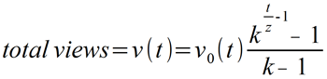

http://frac.tl/the-viral-growth-enigma-how-math-can-quantify-online-sharing/
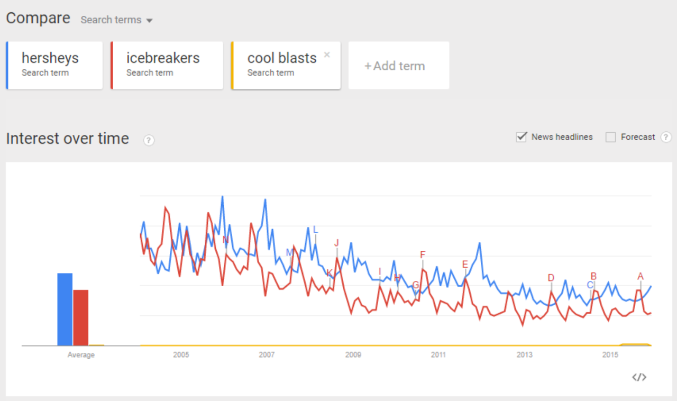
- Primary Research Questionnaire
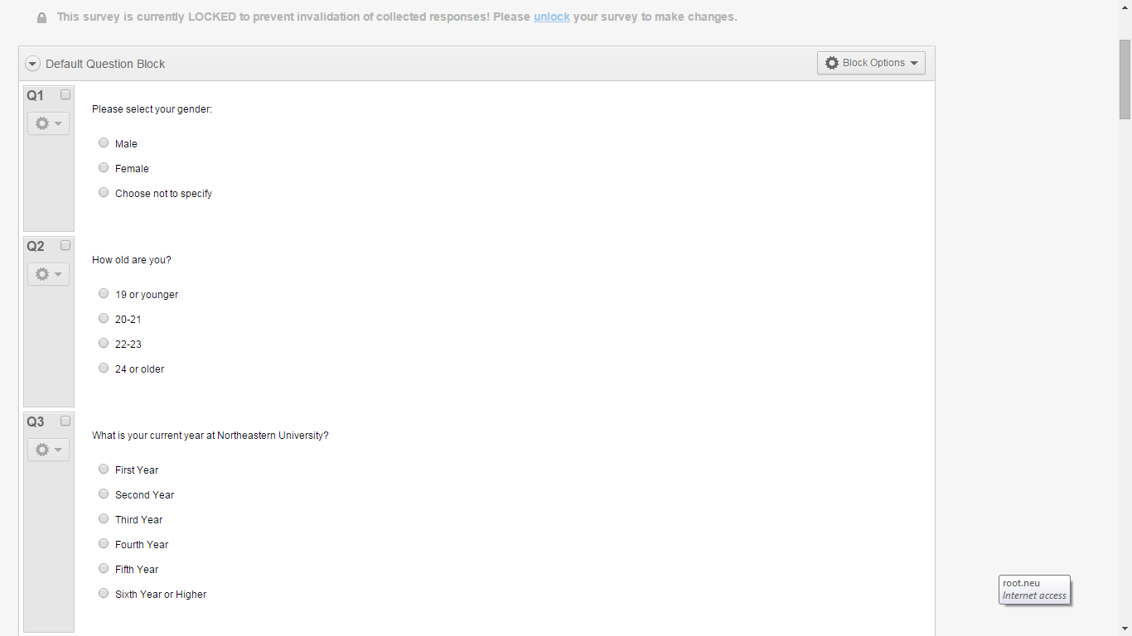
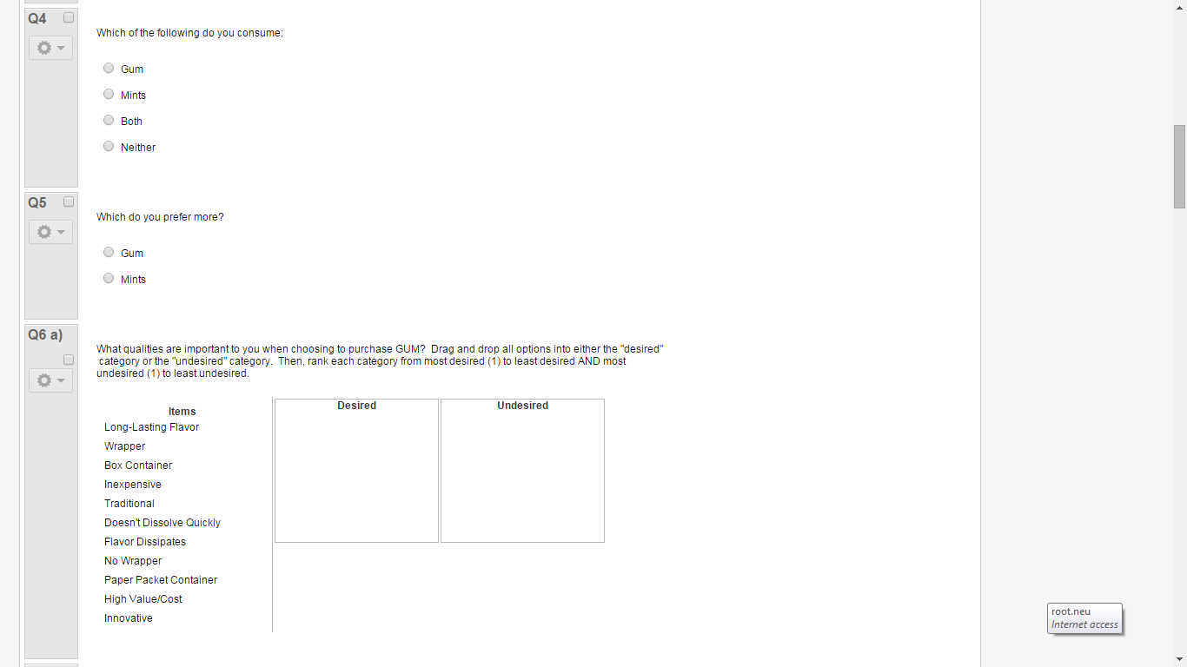
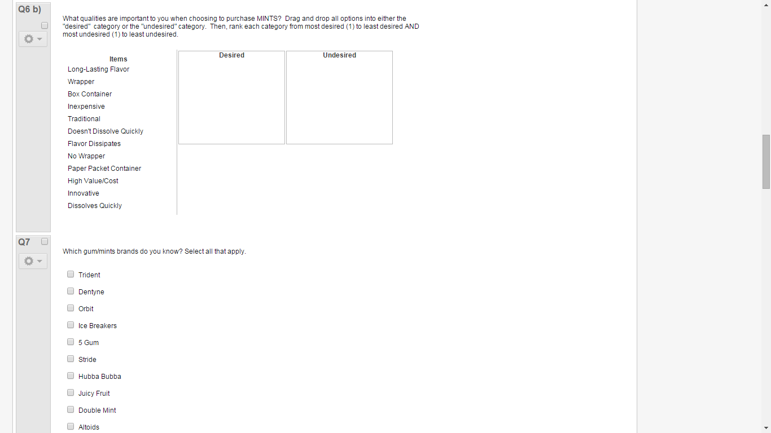
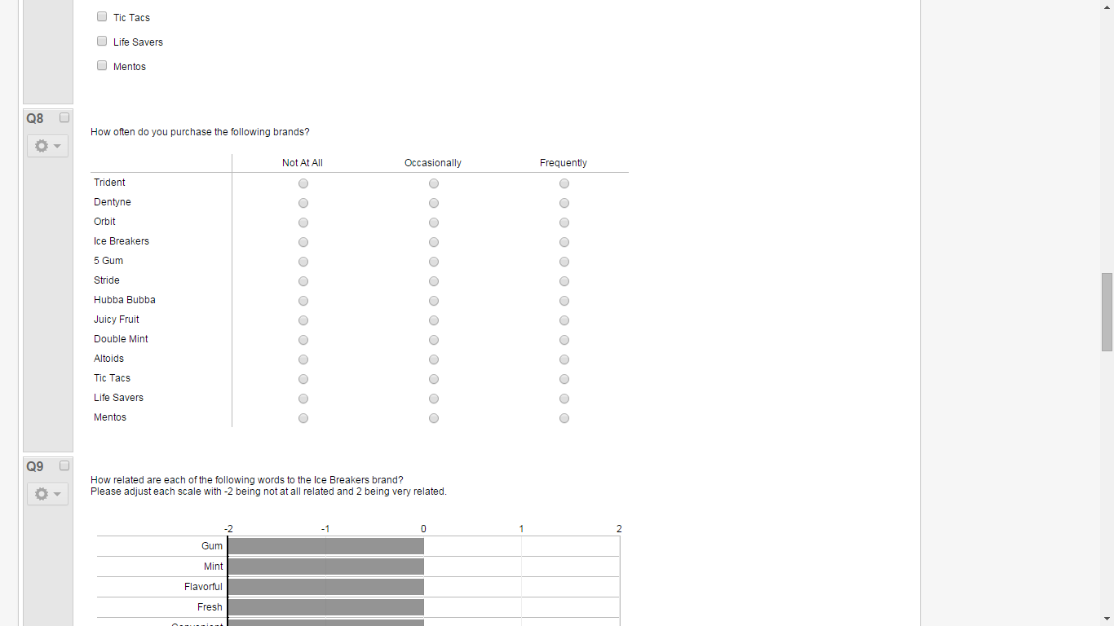
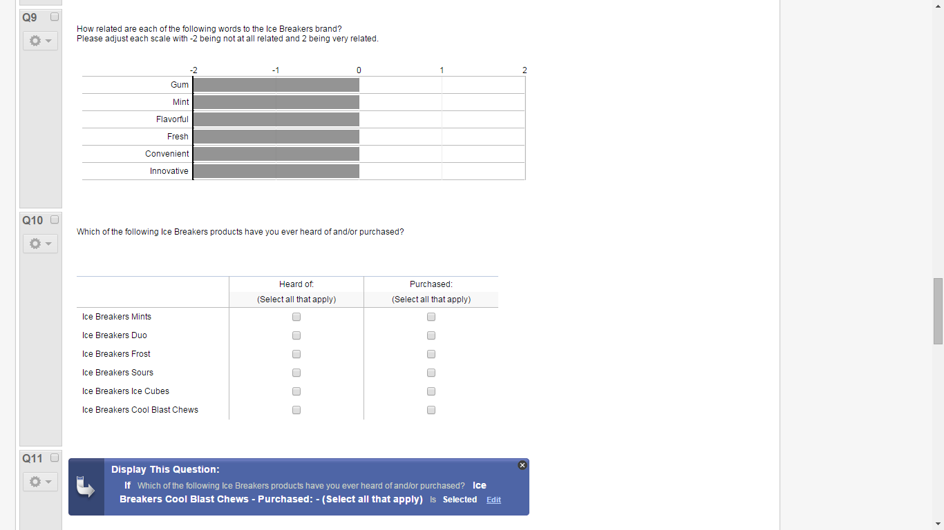
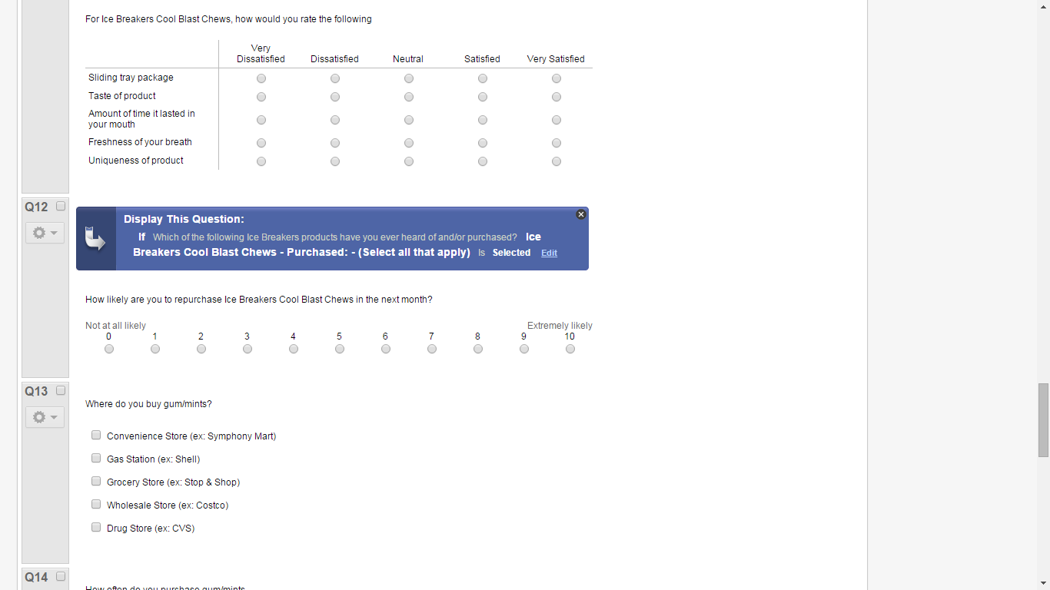

B. Cool Blasts Master Marketing Budget
COOL BLASTS Budget | Quantity | Cost | Total Cost | % of Total Budget
Facebook/Instagram Ad Cost (3.9-8.4m views/day for a mth) | 4 | $1,000,000 | $4,000,000 | 40.00%
Snapchat Ad Cost (per day) | 4 | $750,000 | $3,000,000 | 30.00%
Magazine Ad - Inside Cover | 4 | $500,000 | $2,000,000 | 20.00%
Twitter Hashtag Promotion (per day) | 4 | $200,000 | $800,000 | 8.00%
Magazine Ad - Large | 4 | $20,000 | $80,000 | 0.80%
Celebrity Endorsement | 10 | $10,000 | $100,000 | 1.00%
Magazine Ad - Small | 30 | $500 | $15,000 | 0.15%
Coupon Costs | 100,000 | $0.05 | $5,000 | 0.05%
Totals | - | - | $10,000,000 | 100.00%

SPSS Output - Ashley to attach in word doc
Budget - Alex
Timeline of Promotions - Alex
Sales Forecast - Kevin

BIBLIOGRAPHY
Euromonitor. "Leading U.S. Chewing Gum Brands Based on Sales, 2013 | Statistic." Statista. N.p., 2015. Web. 23 Nov. 2015. <http://www.statista.com/statistics/295031/leading-us-chewing-gum-brands-based-on-sales/>.
Ferdman, Roberto A. "Which Gum Americans Are Chewing on These Days." Quartz. N.p., 22 Mar. 2014. Web. 20 Nov. 2015. <http://qz.com/190895/which-gum-americans-are-chewing-on-these-days/>.
Kaplan, Karen. "The Paradox of Millennial Sex: More Casual Hookups, Fewer Partners." Los Angeles Times. Los Angeles Times, 09 May 2015. Web. 01 Dec. 2015. <http://www.latimes.com/science/sciencenow/la-sci-sn-millennials-sex-attitudes-20150508-story.html>.
McMillan, Bo. "Gum: Here's One Market Bubble That Hasn't Popped." CNBC. N.p., 04 Aug. 2014. Web. 23 Oct. 2015. <http://www.cnbc.com/2014/07/31/heres-one-market-bubble-that-hasnt-popped.html>.
"Millennials: Breaking the Myths." Nielsen. The Nielsen Company, 2014. Web. 23 Nov. 2015. <http://www.nielsen.com/us/en/insights/reports/2014/millennials-breaking-the-myths.html>.
"News." The Globe and Mail. The Globe and Mail, 4 Feb. 2014. Web. 23 Oct. 2015. <http://www.theglobeandmail.com/report-on-business/chewing-gum-losing-grip-on-north-american-market/article22796589/>.
Newbrun, Enest, Dr. "Bad Breath:More than Just Embarrassing." Dear Doctor: Dentistry and Oral Health. N.p., 1 Feb. 2008. Web. 1 Dec. 2015. <http://www.deardoctor.com/articles/bad-breath/index.php>.
Nieburg, Oliver. "'You're Going to See a Turnaround in the Gum Category,' Says Hershey Exec." ConfectioneryNews.com. N.p., 20 Mar. 2015. Web. 11 Nov. 2015. <http://www.confectionerynews.com/Markets/Chewing-gum-market-forecasts-Turnaround-coming>.
Nieburg, Oliver. "Is Functional Chewing Gum the Answer to the Category's Woes?" ConfectioneryNews.com. N.p., 08 July 2014. Web. 23 Nov. 2015. <http://www.confectionerynews.com/Markets/Functional-chewing-gum-market-opportunities>.
Nieburg, Oliver. "Wearables, Beacons and Smart Diplays: Eight Tech Startups to Help Mondelēz Tap Millennials." ConfectioneryNews.com. N.p., 4 Sept. 2015. Web. 28 Oct. 2015. <http://www.confectionerynews.com/Sectors/Gum/Mondelez-unveils-eight-marketing-technology-partnerships>.
Nieburg, Oliver. "Gum Packs of the Future: Flip Top Cartons with Fewer Pieces." ConfectioneryNews.com. N.p., 02 Nov. 2014. Web. 23 Nov. 2015. <http://www.confectionerynews.com/Processing-Packaging/Future-of-chewing-gum-packaging>.
Nicole, Blair. "Hookup Culture: Is Finding Real Love Possible Anymore?"The Inquisitr News. Inquisitr, 7 Dec. 2015. Web. 07 Dec. 2015. <http://www.inquisitr.com/2617610/hookup-culture-is-finding-real-love-possible-anymore/>.
ProFresh. "Be Kind to Your Valentine: Bad Breath Is #1 Turnoff." ProFresh. N.p., 11 Feb. 2014. Web. 01 Dec. 2015. <https://profreshcuresbadbreath.wordpress.com/2014/02/11/be-kind-to-your-valentine-bad-breath-is-1-turnoff/>.
SwimSwam. "Hershey Candy Company Partners with U.S. Olympic Committee." SwimSwam. N.p., 13 Oct. 2015. Web. 23 Nov. 2015. <http://swimswam.com/hershey-candy-company-partners-with-u-s-olympic-committee/>.
"The Hershey Company Continues Leadership in Convenience and Identifies Consumer Trends." BussinessWire. N.p., 12 Oct. 2015. Web. 23 Nov. 2015. <http://www.businesswire.com/news/home/20151012005719/en/>.
Van Bodegraven, Art. "Winning the Losing Battle of SKU Proliferation." Shelf Plus. N.p., 2015. Web. 11 Nov. 2015. <http://www.shelfplus.com/material-handling-hotline/winning-battle-sku-proliferation/>.
Zinck, Shaun. "Hershey Sued over Packaging of Its Ice Breakers Gum Brand." Hershey Sued over Packaging of Its Ice Breakers Gum Brand. N.p., 21 July 2015. Web. 23 Nov. 2015. <http://legalnewsline.com/stories/510629393-hershey-sued-over-packaging-of-its-ice-breakers-gum-brand>
“Millennials - Breaking the Myth.” Nielsen. Feb 2014 (2014): 1-41. Print.
<millennials-breaking-the-myths.html>

Advertising Tools, Facebook. "Facebook." Facebook. N.p., n.d. Web. 07 Dec. 2015. <https://www.facebook.com/ads/manager/creation/creation/?act=62944988&pid=p1>.
Alleger, Jason. "How Much Do Ads on YouTube Cost?" Penna Powers. N.p., 06 Aug. 2012. Web. 07 Dec. 2015. <http://www.pennapowers.com/how-much-do-ads-on-youtube-cost/>.
Beese, Jennifer. "Twitter Promoted Trends Will Now Cost You $200,000 Daily | Sprout Social." Sprout Social. N.p., 11 Feb. 2013. Web. 07 Dec. 2015. <http://sproutsocial.com/insights/twitter-promoted-trends-cost/>.
"Cool Blast Challenge." YouTube. YouTube, n.d. Web. 07 Dec. 2015. <https://www.youtube.com/watch?v=ugtVfoxzYY4>.
Drexler, Dr. Peggy. "Millennial Women Are Taking a Laissez-Faire Approach to Romance." The Huffington Post. TheHuffingtonPost.com, n.d. Web. 07 Dec. 2015. <http://www.huffingtonpost.com/peggy-drexler/-millennial-women-are-tak_b_6578116.html>.
Drexler, Dr. Peggy. "Millennial Women Are Taking a Laissez-Faire Approach to Romance." The Huffington Post. TheHuffingtonPost.com, n.d. Web. 07 Dec. 2015. <http://www.huffingtonpost.com/peggy-drexler/-millennial-women-are-tak_b_6578116.html>.
Nicole, Blair. "Hookup Culture: Is Finding Real Love Possible Anymore?" The Inquisitr News. N.p., n.d. Web. 07 Dec. 2015. <http://www.inquisitr.com/2617610/hookup-culture-is-finding-real-love-possible-anymore/>.
Press, Associated. "Tweeting for Money: The Twitter Checks Cashed by Celebrities like Khloe Kardashian ($8,000), Charlie Sheen ($9,500) and Even Jailbird LiLo ($3,500)." Mail Online. Associated Newspapers, n.d. Web. 07 Dec. 2015. <http://www.dailymail.co.uk/news/article-2057268/Twitter-endorsements-Khloe-Kardashian-costs-8k-Charlie-Sheen-9-5k-Lindsay-Lohan-3-5k.html>.
Sheehan, Daniel. "Swipe Right for Tinder Advertising - FleishmanHillard." FleishmanHillard. N.p., 16 June 2015. Web. 07 Dec. 2015. <http://fleishmanhillard.com/2015/06/true/swipe-right-for-tinder-advertising/>.
Sloane, Garett. "Snapchat Is Asking Brands for $750,000 to Advertise and Won't Budge." AdWeek. N.p., n.d. Web. 07 Dec. 2015. <http://www.adweek.com/news/technology/snapchat-asks-brands-750000-advertise-and-wont-budge-162359>.

